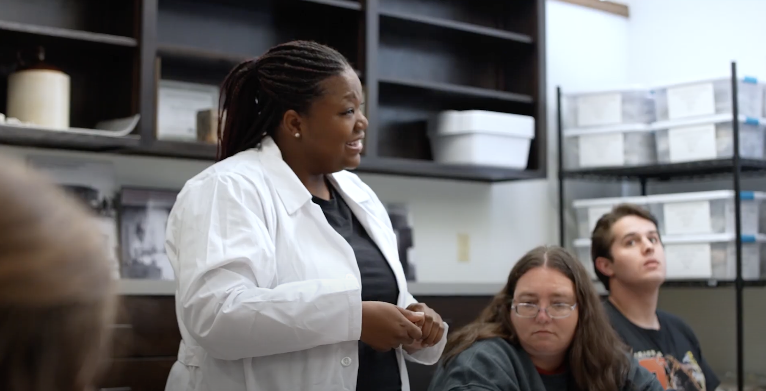

“Believe in yourself, learn, and never stop wanting to build a better world.”

-Mary McLleod Bethune

My Teaching Philosophy (nice cursive font)

My approach to teaching is a reflection of my mission to make the world of archaeology and academia a better place but also reflects my love for people and my desire to highlight the diversity of lived experiences across the Diaspora. African Diaspora archaeology is a discipline that invites students to bear witness to the tangible and intangible heritage of people of African descent around the world, but as a witness they are then also called to never forget what they learned.

Photos of me teaching that can be incorporated on the page

Below are 3 options

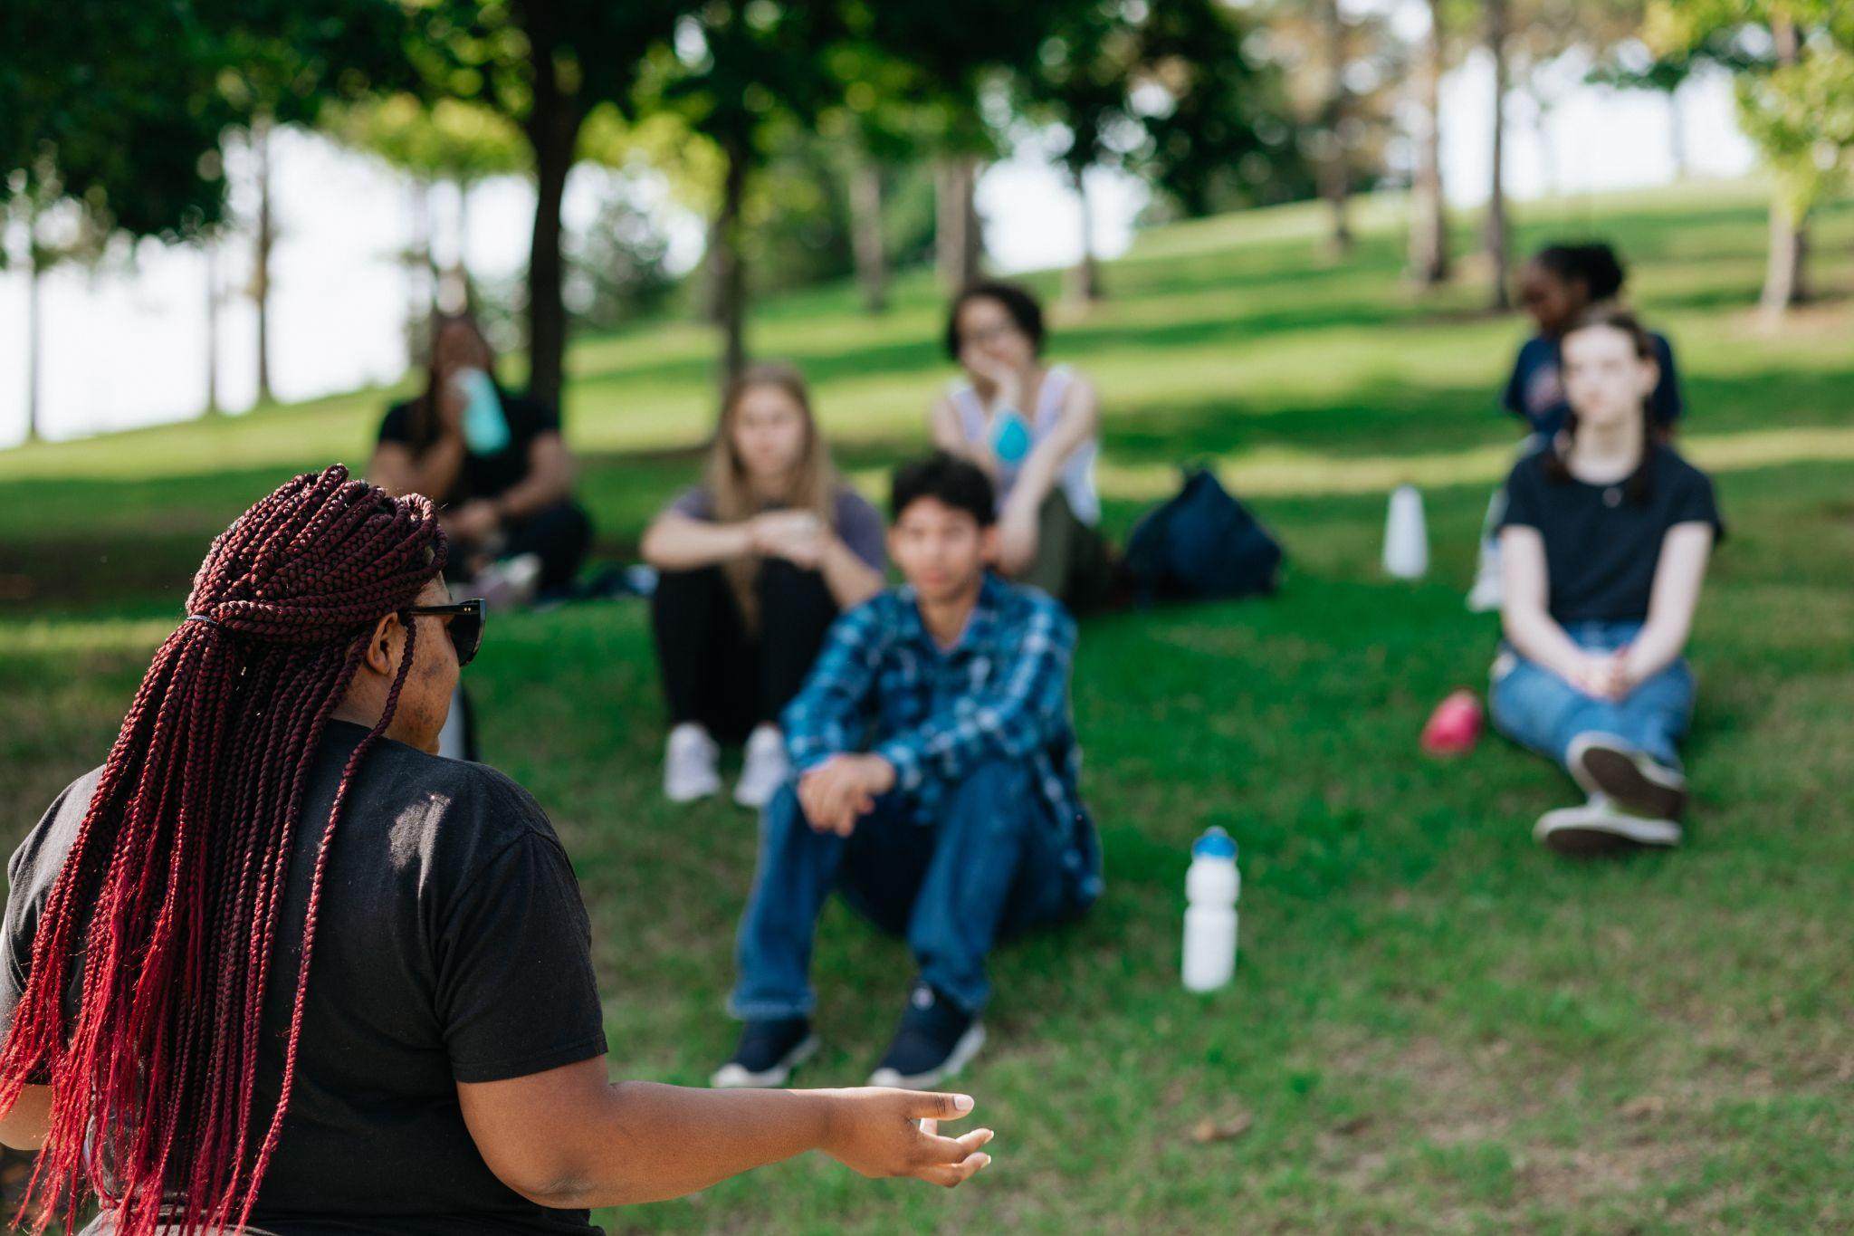

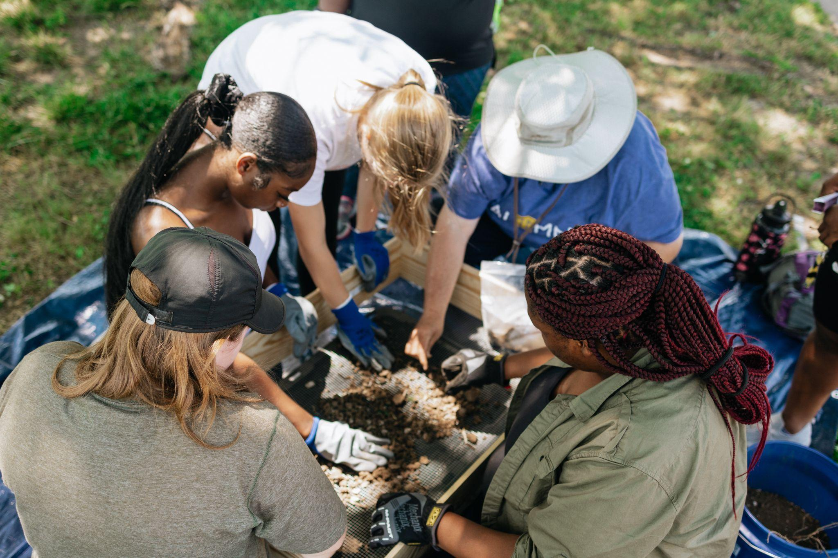

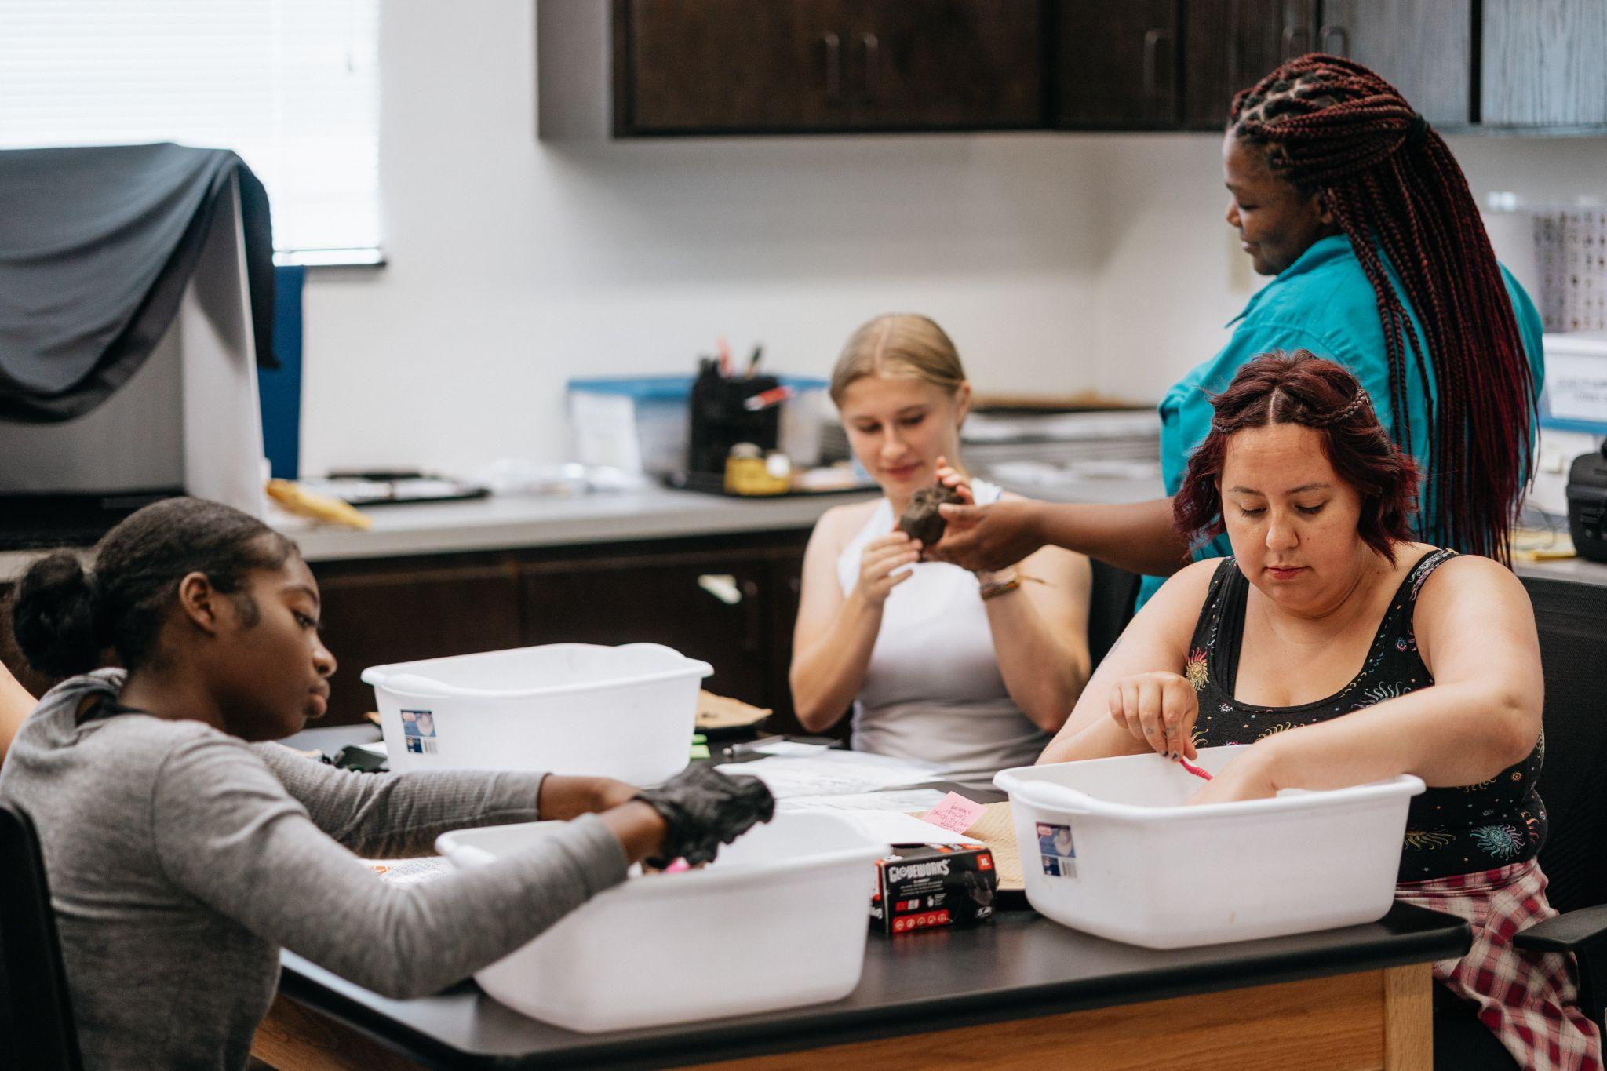

**Can you make the course descriptions a drop down feature?**

**Similar to the following page** [**https://sites.google.com/view/archaeology-beyondthedecade/program?authuser=0**](https://sites.google.com/view/archaeology-beyondthedecade/program?authuser=0)

K-12 Teaching

National Geographic Explorer Classroom

*Stories and Wisdom Within the Land Around Us* <https://www.youtube.com/watch?v=fQPsIJ095nI>

Black History Saturdays

<https://blackhistorysaturdays23.carrd.co/>

*Archaeology Night Live*

Video of Archaeology Night Live

Uploaded into dropbox folder

Undergrad & Graduate Teaching

Virtual/Hybrid (include thumbnail image of all the courses with websites attached)

*Anthropologies of Race in the Age of Black Lives Matter*

<https://anthropologyofrace.edublogs.org/>

This First Year Seminar course introduces students to the world of anthropology and provides an opportunity to study the controversial topic of race through an anthropological lens. Using the four subfields of anthropology and recent trends in social justice movements, we will critically examine the concepts of race and racism from multiple perspectives. Looking to historical and present day case studies, students will learn the myriad ways that race continues to shape the lived experiences of those around us and especially those who continue to fight against anti-Black racism. Together we will explore the usefulness of anthropology to interrogate race, ranging from linguistic studies of African-American Vernacular English and the phenomenon known as code switching, to debates surrounding a possible biological basis for racial categories, to questions about the cause of differences in skin color. The focus of this course is to learn the double-edged power of anthropology, which can be used to either support institutional racism, white supremacy, and neo-colonial ideals or as a critical tool for social justice to tear down racism in all its forms.

*Archaeology and History of the African Diaspora*

<https://blackheritagedig.edublogs.org/>

This course is open to both undergraduate and graduate students and examines the archaeological sites and cultural material left behind by people of African descent before, during, and after The Trans-Atlantic Slave Trade. This course uses a blend of archaeological and historical evidence to examine the diversity of lived experiences that existed for enslaved and free Black people around the world, from the earliest “slave jails” and castles in West Africa to the diamond mines of Brazil. The aim of this course is to not only help students understand the world of diversity represented by people of African descent across the Diaspora, but to also examine archaeology’s role in bringing their stories to light. Through this blog, students enrolled in this course will share their experiences as they explore the world of African Diaspora Archaeology for the first time.

*Archaeology of Black Heritage in Oklahoma*

[*https://okblackheritagedig.edublogs.org/*](https://okblackheritagedig.edublogs.org/)

*The class is made up of a mix of undergraduate and graduate students, who are using archives, archaeology, genealogy, oral history, digital storytelling, and geospatial tool*s, to learn the power of counter mapping and vernacular history collection to challenge mainstream, single story narratives of history and reimagine cultural heritage landscapes. Divided into three parts, this course explores the historical context of the past, the tools used in the present to integrate this history, and how we can build a more just future going forward. Blending archaeology, history, and digital humanities tools, students will trace the stories of Black families in Oklahoma from removal and displacement to the establishment of Black colleges, towns, and one of the most prosperous communities in the world- Tulsa’s Black Wall Street. As we examine the role that race played in Oklahoma’s shifting landscape and the lasting impact of the Tulsa Race Massacre 100 years later, students will explore common topics in Oklahoma history specifically from the perspective of the Black men, women and children who lived during these times and the objects they left behind. Course topics include the early intersections of race within Indian Territory and the fight for Freedpeople’s rights, Black war veterans and Buffalo Soldiers on Oklahoma’s frontier, Black cowboys and lawmen/women, Oklahoma’s All-Black Towns, Anti-Black Violence and Community Resilience, the search for safety in the Jim Crow South, and stories of success even in the midst of a landscape of racial terror.

<https://sarweb.org/education/classes/>

*Online Course*

Unearthing Violence: Archaeology in the Aftermath of the Tulsa Race Massacre

Session 1: Restorative Justice and Community Led Archaeology

Session 2: Finding Signs of Life in the Aftermath of a Massacre

Can be incorporated at the end of the online teaching section

Teaching Demo of Online Course

<https://youtu.be/b1wzNLSnQSk>

In-person

*Cultures Before History*

*This course introduces the methods and results of prehistoric archaeological research from around the world. Concepts range from the basic principles of archaeology to larger questions about human origins and the rise and fall of complex societies in the prehistoric world. Illustrations of prehistoric societies from both the Old and New World are used to introduce the goals, assumptions, and techniques of modern archaeology. This course can be used to fulfill a requirement in Block II and the anthropology major or minor.*

*Roots of Hamilton: Relics of Resistance across the Black Atlantic World*

*This interdisciplinary, team-taught course uses the life of Alexander Hamilton as a window through which to view the different forms of resistance and revolution that animated the Black Atlantic world. Tracing the roots of Hamilton entails an intellectual journey through the Caribbean and America, where we will examine black resistance and the physical objects that connect to the resiliency of the black community, as well as study the legal recourse taken by whites in the aftermath of such resistance. After critically digesting historical and anthropological texts during the semester, we will travel to St. Croix to experience firsthand the physical and historical spaces in which black resistance occurred. In sum, this course will explore the relationship between America and its Caribbean neighbors through the perspectives of archaeology and history, from revolution to revolution, and will end by considering the modern repercussions of these historical events.*

<https://www.facebook.com/watch/?v=1055606557930145>

Photos from this class have been uploaded to the dropbox

*Transforming Historical Archaeology Methods*

*This graduate seminar explores recent developments in historical archaeology methods in an effort to investigate the tangible and intangible evidence of heritage in the Americas. This course uses new community-based approaches in material culture studies to transform our understanding of objects and sites of living heritage along with archaeology’s role in the reclamation of power. This graduate methods course will allow students to gain advanced knowledge and training in the field of historical archaeology, while exploring where this discipline fits in the larger world of anthropology, and some of the key issues facing historical archaeologists today. Through readings, seminar discussions, hands-on activities, field trips, and the completion of a research portfolio, this course provides an opportunity for students to develop and apply new skills while critically examining the future of this young field.*

*Comparative Archaeology of Slavery in the Danish West Indies*

*This course covers the archaeology of enslavement in the former Danish West Indies (currently US Virgin Islands) specifically focusing on a sample of the over 300 plantation estates that once covered the island of St. Croix. Readings in the course will explore the history of some plantation estates on island such as Estate Little Princess, but will also provide an opportunity to compare sites of African heritage in the Danish West Indies/Virgin Islands to sites around the world. In reading about sites of African and Crucian heritage in St. Croix, the goal will be to not only gain an appreciation for the unique cultural heritage and archaeological history of the Virgin Islands, but to also develop an understanding of how archaeological research is conducted from the initial research and data gathering stages to the dissemination of results and collections management. In order to provide a hands-on introduction to the stages of archaeological research, students will receive unprecedented access to training in both field and lab methods, spending one week as a participant in the Estate Little Princess Archaeological Field School in St. Croix and another week as a participant in a special DAACS cataloguing workshop in Tulsa, OK at the Historical Archaeology and Heritage Studies Laboratory. This class is designed to not only expose students to the research process but to also provide the opportunity for students to engage in the process of archaeology on a deeper level by participating in hands-on training opportunities, writing site reports, developing their own research proposal, and identifying funding streams in a low stakes environment.*

Video of me teaching in the field

Uploaded to dropbox file

Request link button for me to visit your class for a guest lecture

Request link for button recommendation letter request